# CIS11 Project Part 1 Team Task Assignment

Team Name: Flying Spaghetti Monster

Team Members:

Samuel Elizarraras  
 Randy Son

Allocated Tasks for each member:

1. Multi-character input
2. Create stack for test scores
3. Write test scores to test score array
4. Minimum function
5. Maximum function
6. Average function
7. Output to console

Projected Task Completion Timeline:

5/16/19: Samuel - Multi-character input

Randy - Create stack for test scores, pop stack into test score array

5/23/19: Minimum, maximum, and average function

5/29/19: Output data, test program

Flowchart  
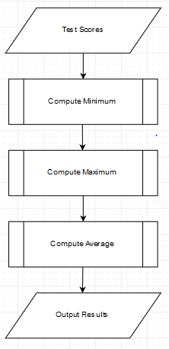

Pseudocode